**DATA WAREHOUSE ASSIGNMENT :1**

**Design Data Warehouses For Given Below Products:**

**1. Design a Data Warehouse for IPL Cricket Tournament (Asked in Flipkart Interview for**

**Senior Data Engineer role):**

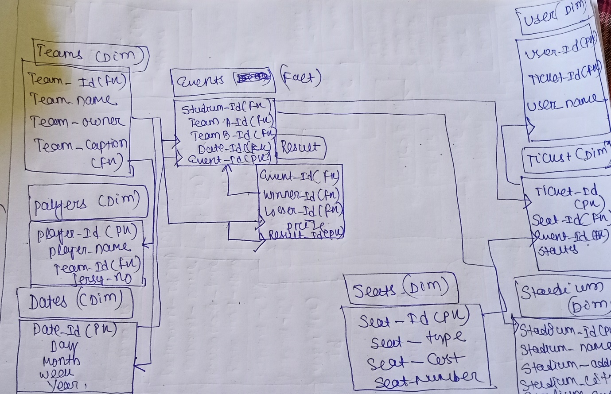

**2. Design a Data Warehouse for Food delivery app like Swiggy, Zomato (Asked in Grab**

**for Data Engineer role)**

**3. Design a Data Warehouse for cab ride service like Uber, Lyft (Asked in Google for Data**

**Engineer role)**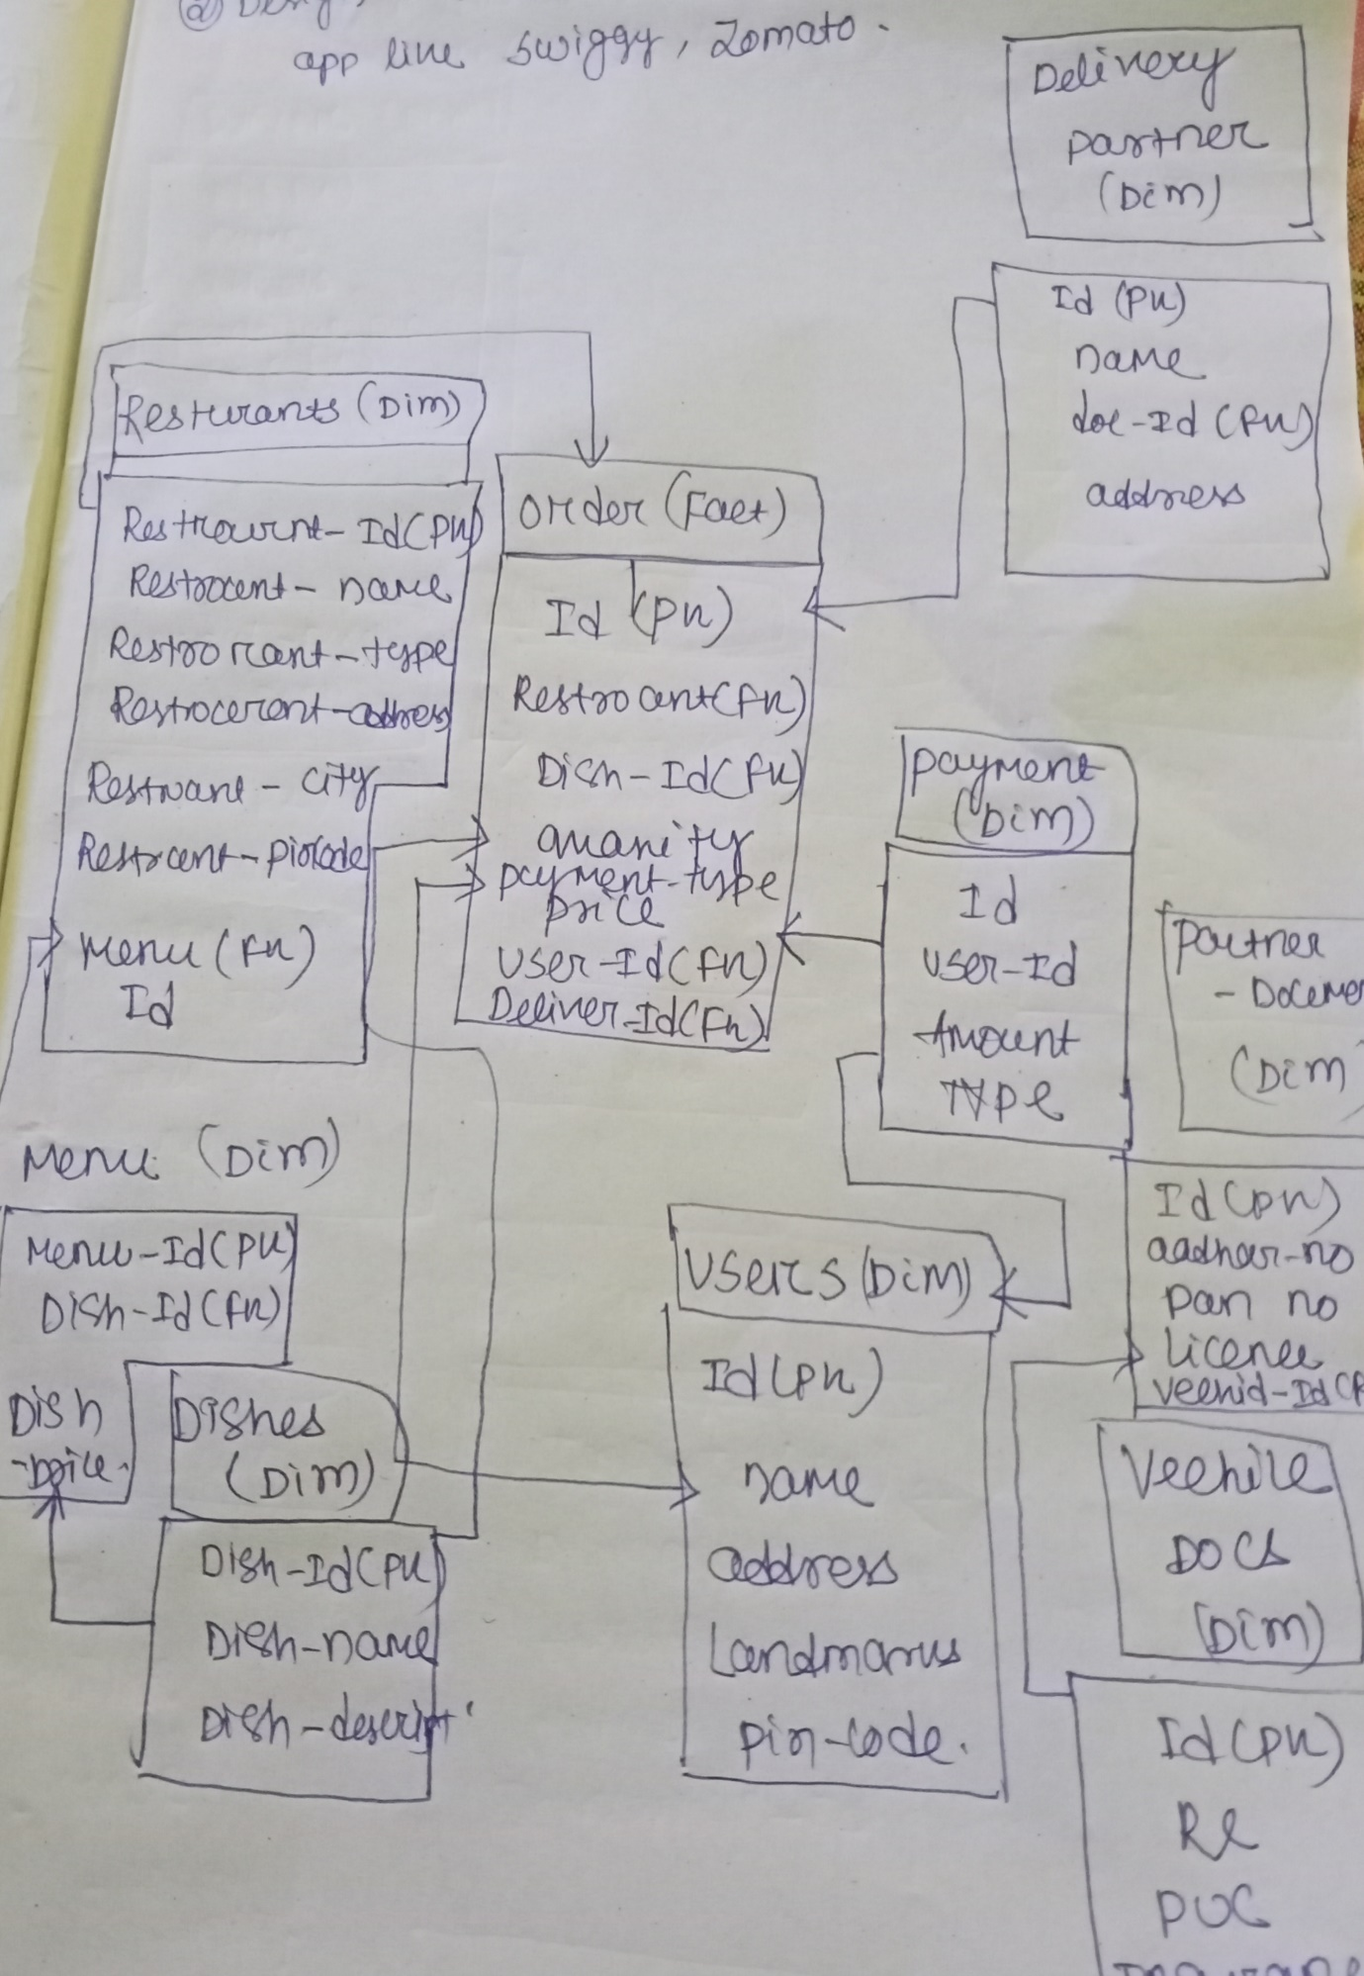

**3. Design a Data Warehouse for cab ride service like Uber, Lyft (Asked in Google for Data**

**Engineer role)**

